HealthConnect

Architecture Document
Work by: Renis Hila

Table of Contents
Introduction 3
C1: System Context Diagram 3
C2: Container Diagram 4
C3: Component Diagram (Inside API Layer) 5
C4: Sequence Diagram (User Register with Kafka Event flow) 6
Technology Justification and Trade-Offs 7
Frontend: React with Next.js 7
Backend Framework: Node.js with Express (micro ser no back) 7
API Gateway 8
Authentication & Authorization: Keycloak (OAuth2, JWT) 8
Database Layer: PostgreSQL (with optional MongoDB) 9
Real-Time Communication: WebSockets and Kafka 9
Monitoring & Logging: Prometheus, Grafana, ELK 10
Security & Compliance Fit 10

Introduction
HealthConnect is a healthcare communication system designed to securely connect patients, doctors, pharmacies, and administrators in a scalable and GDPR-compliant way. The application is built with a strong focus on modularity, scalability, and security, ensuring it can adapt to future needs while maintaining compliance with healthcare standards.
This document outlines the system architecture using the C4 model (C1–C3 diagrams) and provides a justification for the chosen technologies.

C1: System Context Diagram
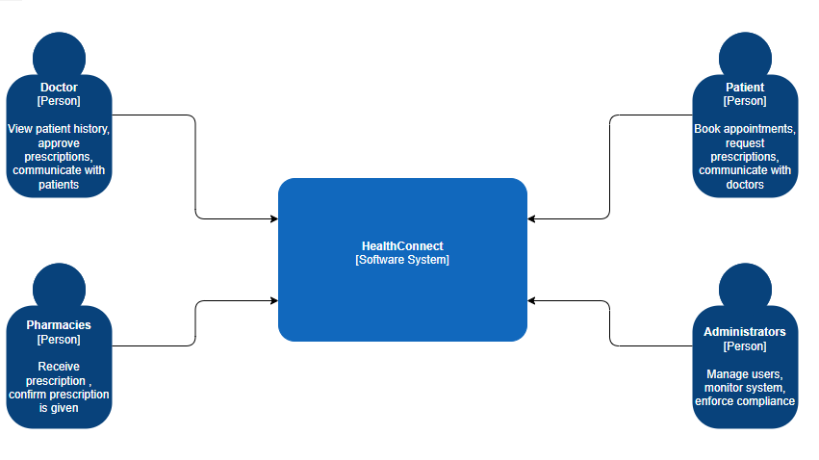
This diagram outlines the HealthConnect system and its users. Patients book appointments and request prescriptions, while Doctors view histories and approve them. Pharmacies confirm prescriptions, and Administrators manage the system and ensure its compliance.

C2: Container Diagram
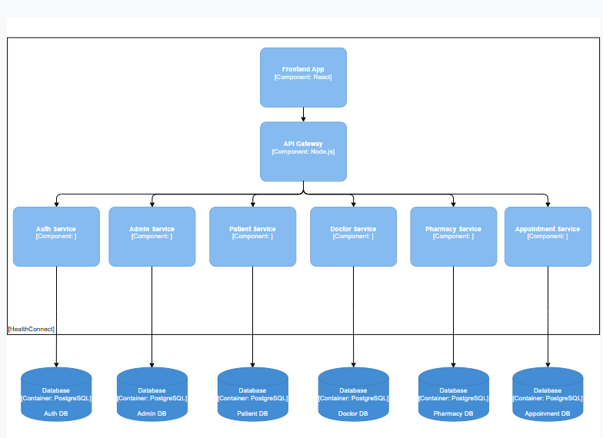

This diagram shows a detailed microservices architecture for HealthConnect. The React Frontend connects via a Node.js API Gateway to independent backend services (Auth, Patient, Doctor, etc.). Each service has its own dedicated PostgreSQL database, implementing a database-per-service pattern to ensure loose coupling and data autonomy.

C3: Component Diagram (Inside API Layer)
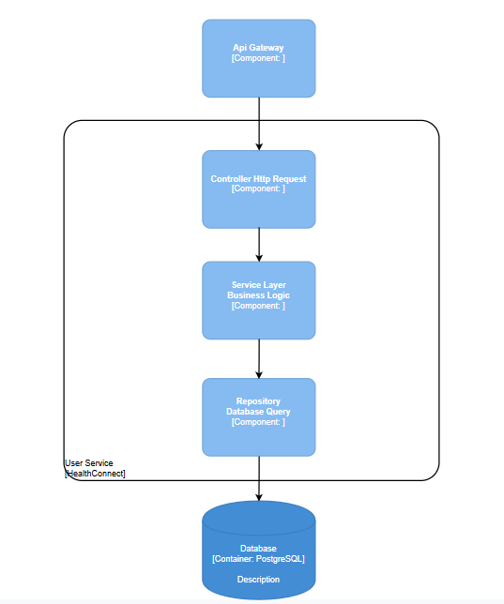
This diagram shows the internal structure of the User Service. It follows a layered architecture, where an HTTP Controller receives requests and passes them to the Service Layer for business logic. The Service Layer then uses the Repository component to handle all database queries to the PostgreSQL Database.

C4: Sequence Diagram (User Register with Kafka Event flow)
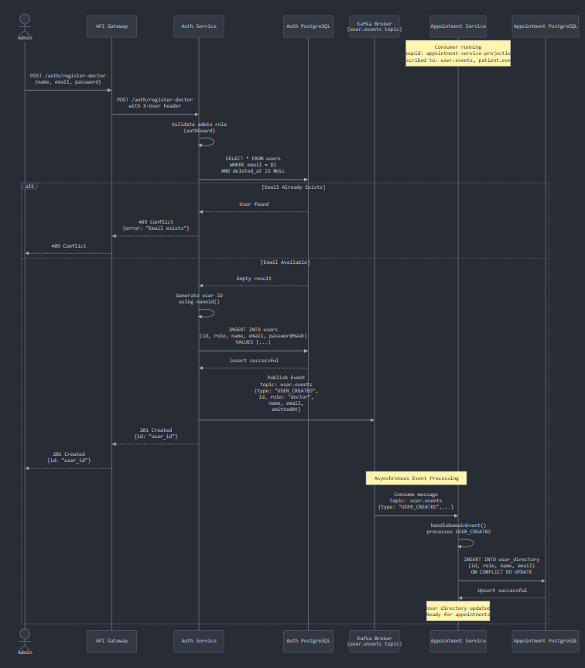
This diagram illustrates the user registration flow for a new doctor. An API request is validated, a new user record is created in the Auth Service's database, and a USER_CREATED event is published. This event is then consumed by other services, like the User Directory and Appointment Service, to create their own local copies of the user data, ensuring information is consistent across the system.

Technology Justification and Trade-Offs
The technology stack for HealthConnect was selected after weighing scalability, maintainability, security, and compliance requirements. Below is a reasoned justification of each major choice, including trade-offs compared to common alternatives.

Frontend: React with Next.js
Reasoning: React’s component model makes the UI modular, testable, and reusable. Next.js adds server-side rendering (SSR) and static site generation (SSG), which improve perceived performance and SEO — critical for patient-facing portals. The rich ecosystem (form validation, accessibility, UI libraries) accelerates development.
Alternatives considered:
- Angular was rejected because its steeper learning curve and opinionated structure slow down small-team iteration.
- Vue.js is lightweight and flexible but has a smaller enterprise adoption and fewer ready-made healthcare-grade libraries.
Conclusion: React/Next.js balances developer productivity and scalability, while ensuring accessibility and long-term maintainability.

Backend Framework: Node.js with Express (micro ser no back)
Reasoning: Node.js is highly efficient for I/O-heavy workloads (e.g., multiple concurrent requests, real-time chat). Express is lightweight and unopinionated, giving flexibility in designing APIs. Its asynchronous nature also supports future extensions like real-time monitoring.
Alternatives considered:
- Spring Boot (Java) offers strong enterprise features and better type safety but comes with higher memory overhead and slower startup times. It also requires a larger developer skillset investment.
- Django (Python) provides a batteries-included approach, but it is synchronous by default and less optimized for real-time scenarios.
Conclusion: Node.js/Express offers faster iteration and better scalability for the event-driven nature of HealthConnect, making it more suitable than heavier frameworks.

API Gateway
Reasoning: A central API gateway provides a single-entry point, handling cross-cutting concerns like authentication, rate limiting, and monitoring. This enforces uniform security and simplifies scaling by decoupling services.
Alternatives considered:
- Direct service exposure (no gateway) was ruled out because it complicates authentication and increases the attack surface.
- Service Mesh (Istio, Linkerd) could offer richer features (e.g., retries, traffic shaping), but adds significant operational complexity, which is unnecessary for the project’s current scale.
Conclusion: API Gateway is a pragmatic choice — secure, lightweight, and scalable — while leaving open the option to evolve into a service mesh later.

Authentication & Authorization: Keycloak (OAuth2, JWT)
Reasoning: Keycloak provides identity federation, RBAC, and token management out of the box. It integrates easily with OAuth2 and generates JWTs, which work well in a microservices context.
Alternatives considered:
- Custom auth service was ruled out due to high implementation and maintenance risks (security-critical code should not be reinvented).
- Auth0/Okta are managed services with excellent features, but licensing costs and reliance on third parties for sensitive healthcare data raised compliance concerns.
Conclusion: Keycloak is a strong open-source, self-hosted solution that balances security, compliance, and cost.

Database Layer: PostgreSQL (with optional MongoDB)
Reasoning: PostgreSQL ensures ACID compliance, referential integrity, and strong transactional guarantees — essential for appointments, prescriptions. It also supports advanced features like JSON storage for semi-structured data.
Alternatives considered:
- MySQL is simpler but less feature-rich (e.g., weaker JSON and indexing support).
- NoSQL-only (MongoDB/CouchDB) was considered, but pure document databases sacrifice transactional integrity, which healthcare cannot risk.
Conclusion: PostgreSQL provides the reliability needed for healthcare data. MongoDB may supplement it for unstructured content (notes, chat logs), but relational consistency remains the foundation.
For more information about the database schema, please refer to the document titled “HealthConnect – Database Schema Overview.”

Real-Time Communication: WebSockets and Kafka
Reasoning: WebSockets enable low-latency, bidirectional communication (e.g., live chat, notifications). Kafka ensures reliable asynchronous messaging and auditability (e.g., prescription events, pharmacy notifications).
Alternatives considered:
- Polling or long-polling wastes resources and delivers poor user experience.
- RabbitMQ is easier to operate than Kafka but less suitable for high-throughput event streaming.
Conclusion: The combination of WebSockets (for immediate interactions) and Kafka (for durable event workflows) provides the right balance between responsiveness and reliability.

Monitoring & Logging: Prometheus, Grafana, ELK
Reasoning: Healthcare applications require proactive monitoring and complete traceability. Prometheus and Grafana cover performance metrics, while ELK (Elasticsearch, Logstash, Kibana) enables centralized logging and audit trails. This ensures full GDPR accountability: who accessed what data, when, and why.
Alternatives considered:
- Datadog or New Relic offer powerful observability but incur high costs and externalize sensitive log data, which conflicts with GDPR.
- Lightweight logging only (without centralization) would reduce setup time but fail to meet compliance and debugging needs.
Conclusion: Open-source observability tools balance compliance, cost, and functionality, making them ideal for HealthConnect.

Security & Compliance Fit
Every technology was selected with GDPR in mind. PostgreSQL ensures data integrity, Keycloak enforces strict access control, Kafka guarantees event delivery, and ELK provides immutable audit trails. Together, the stack ensures both technical resilience and security, which is critical in healthcare.

